**Author: Praful Yelekar**

**GRIP The Sparks Foundation**

**Role: Data Science & Business Analytics intern**

**Duration:April 2023 (Batch)**

**Task 3: Exploratory Data Analysis - Retail**

(Level Beginner)

**Problem Statement:**

Perform ‘Exploratory Data Analysis’ on the provided dataset ‘SampleSuperstore.csv’. You are the business owner of the retail firm and want to see how your company is performing. You are interested in finding out the weak areas where you can work to make more profit. What all business problems you can derive by looking into the data? You can choose any of the tool of your choice (Python/R/Tableau/PowerBI/Excel)

1. **The Dashboard is Created using PowerBI.**

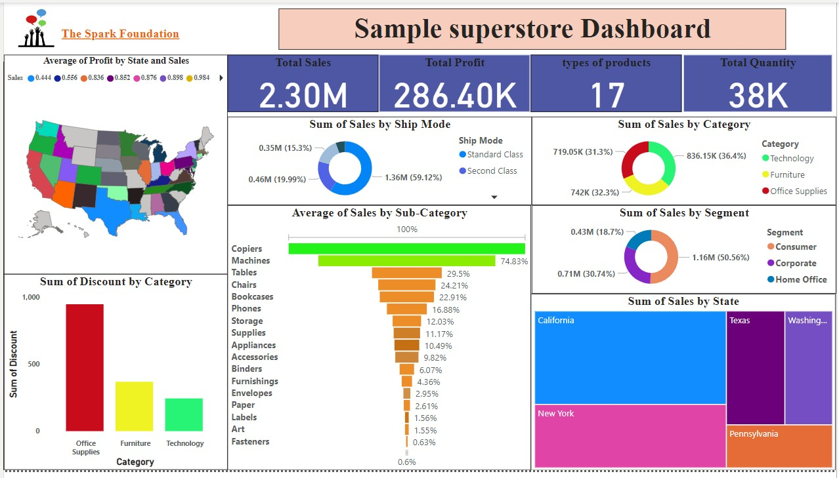

1. **It is observed from the dashboard that the state California has a good profit to sales ratio and is performing good in the market.**

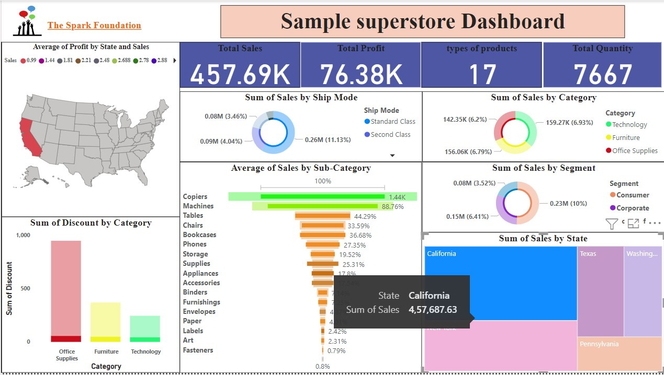

1. **The Highest Sum of sales performing categories are Technology**

It is being observed that the “Technology” and “Office-Supplies” Sub-Category have high profit whereas “Furniture” has less profit.

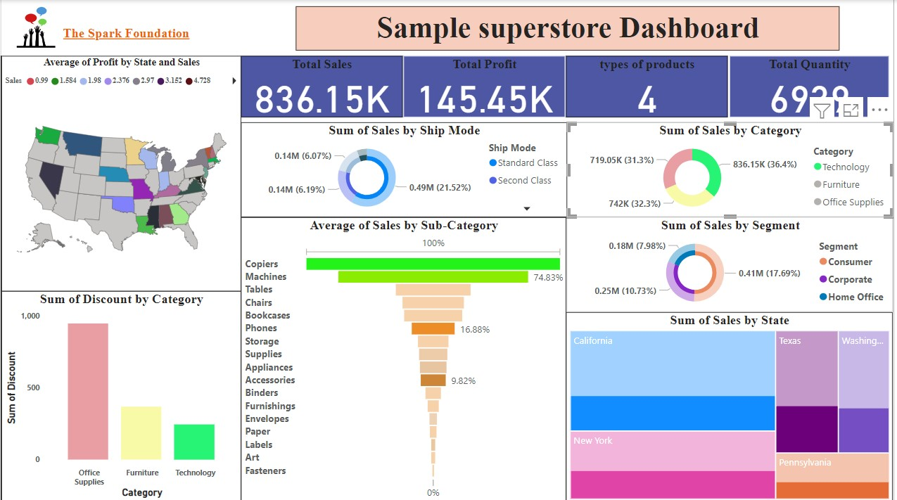

1. **It is observed from the dashboard that the Average of Sales by Sub-Category copiers and is performing good in the market.**

